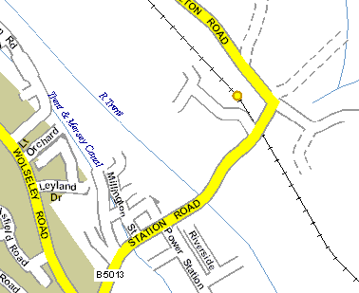

Location:

Unit 15, Riverside
Power Station Road
Rugeley
Staff. WS15 2YR

Contact Phil Butler

